LINUX ASSIGNMENT

Gokula Madhavan B
Department of Information Technology
Sri Sairam Engineering College, chennai

- BASIC COMMANDS:
Commands are actually files containing programs, often written in C. How will you find out in which directory does the file corresponding to the man command resides?

ANS: type man or echo $MAN

How will you find out what is the use of the ps command.
ANS: man ps or whatis ps

- GENERAL UTILITIES:
1)Display the calender for the month of March 2012

ANS: cal mar 2012
2)List all the files and directories of the directory /usr/lib on the terminal. Now put the same information in a file named results.
Display the contents of the file results now.

ANS: ls /usr/lib
ls /usr/lib –l > results
cat results

3.File System

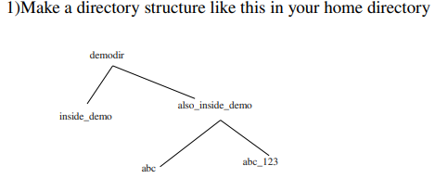

Ans: mkdir demodir
cd demodir
mkdir inside_demo also_inside_demo/abc abc_123

2) Remove the also_inside_demo directory
Ans: cd also_inside_demo
rmdir abc abc_123
cd ..
rmdir also_inside_demo
- FILE ATTRIBUTES:
1. Create a file abc.txt and change the ownership of this file to some other user on your machine,
and also change the group to family.

Ans: cat > abc.txt
sudo chown newowner abc.txt

2. Create a file exercise.txt and make it executable.

Ans: cat > exercise.txt
chmod =x exercise.txt

3. Create a file test.txt on your desktop and identify its inode number, also create a softlink for test.txt in your home.
Ans: cat > test.txt
ls –i test.txt
ln –s text.txt soft.txt

5.Redirection pipes:

- Create a file name error_log in your current directory. Suppose you do not have any file named aa11 in your current directory.

How can you redirect the error message to the file error_log when we apply the command "wc -l aa11" ?

Ans: wc –l aa11 > error_log.txt

How can you ensure that all the error log are appended to the errorlog file?

Ans: wc –l aa11 >> error_log.txt

2. Create files named test1, test2, testa, testb
How can you count the number of files starting with test and then having only one digit in their name using only a single line command ?

Ans: cat > test1
cat > test2
cat > testa
cat > testb

command: ls -1 test[0-9] | wc -l

- Working with Linux Process:
- Open a terminal. Now spawn three shell processes one after another i.e. first spawn one shell, then from the spawned shell, spawn one new shell and so on. Now, how can you see the PID of the current shell ? How can you see the PID of the shell which is the grandparent of the current shell?
Ans: open a terminal enter command ‘bash’
Enter bash again to get child terminal
To get PID oof current terminal: echo $$
To get PID of grandparent : pstree –p | grep PID_of_current bash

- How can you see all the processes (both system & user processes) in your computer? The output can be quite large. How can you view the output as multipage output ? How can you store the output in a file named process_info?
Ans:To view all the process: ps –ef
Multipage output: ps –ef | less
Ps –ef > process_info

7 .Linux Environment
1. How can you know what is the secondary command prompt set your system ?How can you change the secondary command prompt from the default to your username ?
Ans: echo $PS2
To set ps2 to our username: PS2=”$USERNAME> ”
2.How can you ensure that the mv command (used for renaming a file) always asks for permission before overwriting an existing destination file ?
Ans: mv –i file1 destination.

- Create a new user account and home directory called "Duck"
Ans: sudo adduser
Enter the password
Sudo adduser Duck

- Set the user account "Duck's" expirey date as 07 - 01 – 2015
Ans: sudo usermod –e 2015-01-07 duck

- find the id of the user account "Duck"
Ans: id -u duck

- Type df and du commands and see the output on your terminal.
Ans: df
du

5) Type this command on the terminal and see the output :
du -ch *.txt
Ans: du –ch *.txt

6) Delete the user account "Duck" permanently along with its home folder.
Ans: sudo userdel –r duck

8.Simple Filters

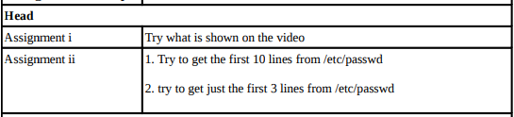
Ans: head /etc/passwd
head –n5 /etc/passwd

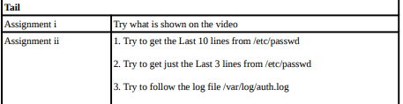
Ans: i) tail etc/passwd
ii) tail –n3 etc/passwd
iii)tail –f /var/log/auth.log
NOTE: sudo need not be used if we are in the root directory

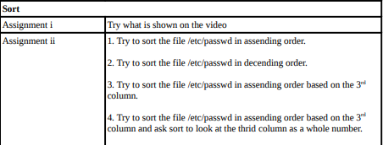

Ans: i) sudo sort etc/passwd
ii) sudo sort –r etc/passwd
iii) sudo sort –t: -k3,3 etc/passwd
iv) sudo sort –t: -k3,3 etc/passwd
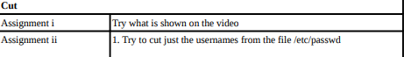
Ans: cut marks.txt –d “ “ –f2
sudo cut etc/passwd –d “ “ –f1

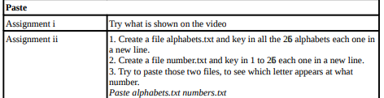

Ans : i) paste numbers.txt marks.txt
ii) 1. Cat > alphabet.txt
2. cat > number.txt
3. paste alphabets.txt numbers.txt

9. Grep command
1) Explore some other commands like -E, + and ?

Ans: -E – extended regular expression: it is used to find longer more complex patters when used with other meta characters such as ‘+’ or ‘?’

‘+’ – it is a meta character used to find continuous occurrence of some patters ex: grep –E ‘[a-z]+’ text.txt

‘?’ – another meta character that acts like a ternary operator
Ex: grep –E ‘colou?r’ text.txt

10. More on grep command
1) List those entries that are 5 letters long and starts with Y
Ans: grep ‘^Y[a-zA-z]{4}$’ test.txt

11. sed command
1) Use the same text file seddemo.txt
2) Try to print records from 6th to 12th line.
Ans:sed –n ‘6,12p’ seddemo.txt

12.More on sed command:
1) Use the same text file seddemo.txt
2) Try to replace or substitute name Ankit with Ashish
Ans: sed ‘s/ankit/ashish/g’ seddemo.txt

